|  |
| --- |
| SWE 573 Software Development Practice, Fall 2016 |
| Health Tracker |
| Requirements Specification Document |

|  |
| --- |
| Can Tuksavul  10-3-2016 |

Contents

Revision History 2

# Revision History

|  |  |  |
| --- | --- | --- |
| **Revision** | **Date** | **Explanation** |
| 0.0.1 | 03.10.2016 | Software Requirements and Use Cases explored. Some mockups has been developed. Questions for customer are prepared. |
| 0.0.2 | 12.10.2016 | Review requirements. Instead of deepening interface design, focus a little more on core functions. |

# Abstract

Health Tracker Project is a software development assignment which aims to simulate major parts of development including project management and testing. As part of Bogazici University SWE 573 course we are asked by our instructor, Suzan Uskudarli, who acts as our customer, patron and senior developer, to document, design and develop an application.

This document will analyze the Project Description: Health Tracker[1], explore the application domain, find users of the system, create scenarios, apply object and function parsing on the found scenarios, put out functional requirements with the help of use case diagrams and explanations, explore existing interfaces to be used with the software and create the initial expected user experience by defining mockups.

This document will be used to facilitate reviews with the customer.

This document will define the scope of the work.

Final version of this document will provide a reference to the Design Document.

# Introduction

Health Tracker is an everyday use tool which shall support quantifying body wellness. It will automate conversion of consumed foods and sports activities to calories. It will generate several reports and lists based on past data. It aims to help keep track of the past progress so that the user can see the trend of their activities and food consumption.

There will be two phases of development. Items marked with the (Phase 2) tag will be implemented in the second phase.

# Overall Description

Main metrics to be used in the software are weight, height, food consumption, activity type and activity duration.

Software shall automate the conversion of food consumption to calories, activity type and duration to expanded calories, weight and height to body mass index[2].

Software shall produce reports based on given time intervals. Smallest time unit for dates is day.

# Constraints

Nutrition suggestions we receive from NDB API states that these values are not suitable for use of children under the age of 4 and pregnant women.

NDB API limits the requests to 10000 for each token. It is assumed that individual users shall retrieve individual API tokens with their email. Spam controls shall be placed for API requests.

# External Software Interfaces

# NDB API

[https://ndb.nal.usda.gov/ndb/doc/index#](https://ndb.nal.usda.gov/ndb/doc/index)

http://www.fda.gov/Food/GuidanceRegulation/GuidanceDocumentsRegulatoryInformation/LabelingNutrition/ucm064928.htm

**N4ZFGssGZVgxc8ZtBOp11B1pRPkXj57IsvKcGpvL**

Account Email: can.tuksavul@gmail.com  
Account ID: 1b66575b-b417-46e7-ab4a-6317852bae1c

[https://api.data.gov/nrel/alt-fuel-stations/v1/nearest.json?**api_key=N4ZFGssGZVgxc8ZtBOp11B1pRPkXj57IsvKcGpvL**&location=Denver+CO](https://api.data.gov/nrel/alt-fuel-stations/v1/nearest.json?api_key=N4ZFGssGZVgxc8ZtBOp11B1pRPkXj57IsvKcGpvL&location=Denver+CO)

# User Scenarios

## Scenario Brief Descriptions

1. **Scenario 1: Registration, Automatic Login, First Food Entry, Automatic report update**
   1. User registers to the system. User is automatically logged into the system.
   2. On first time entry user fills the profile form by entering weight, height, date of birth, gender and notes.
   3. Upon entering required fields, user is directed to main view.
   4. User enters MCD. A list of suggested foods will appear and user chooses MCDONALD’S Hamburger for today.
   5. Report is updated to show the changes.
2. **Scenario 2: Exercise entry and edit**
   1. User logs into the system. He/she enters an exercise for the first time with clicking the action field.
   2. A dropdown suggestion of all available exercises in the system is prompted for auto-fill. The list is updated as the user types.
   3. User then enters the duration.
   4. Report is updated with new data.
   5. He/she realizes that he/she made a mistake and edits the previously entered exercise.
   6. Report is updated to show the new data.
3. **Scenario 3: Searching/Browsing nutrition values (Phase 2)**
   1. User logs into the system. He/she would like to browse
4. **Scenario 4: Recipe creation (Phase 2)**
   1. User logs into the system.
   2. He/she tries to add a food she cooked.
   3. She enters the ingredients one by one with specific amounts.
   4. He/she highlights the items on the list by clicking ‘ctrl’ on the keyboard or by clicking one of them and clicking another with shift.
   5. Once two or more items is selected, the grayed out ‘Create recipe’ button next to the Food List becomes clickable.
   6. He/she enters a name of the recipe. Clicks ‘Create recipe’.
   7. He/she should be prompted to change the name if a same name recipe or food exists, otherwise the list is updated to contain a new item. This item should be expandable to show the contents of the recipe.
   8. A recipe can’t contain other recipes so that we will not deal with recursion. This enforces additional logic during food suggestion to an existing recipe. So in the first version of the software shall not contain editing a recipe.
5. **Scenario 5: Editing a recipe (Phase 2)**
6. **Scenario 6 Viewing advanced Reports (Phase 2)**
   1. User logs into the system. He/she likes to view advanced reports.
7. **Scenario 7: Setting a goal (Phase 2)**
   1. User logs into the system. He/she likes to view past excersizes.
   2. User logs into the system. He/she likes to view past foods.
   3. User logs into the system. He/she likes to find a recipe he/she previously entered.
   4. User logs into the system. He/she sets a goal calorie.
   5. User logs into the system he/she sets a weight goal.

## Scenario Detailed Descriptions

**Scenario 1 Details:**

1. **Scenario 1: Registration, Automatic Login, First Food Entry, Automatic report update**
   1. User registers to the system. User is automatically logged into the system.
      1. Credentials shall be remembered. Cookies shall be used. It might be a good idea to prompt the user that we are using cookies and it might even be better to show a link of our cookie policy where we promise we shall never allow an ad network token shall be placed in the cookies but we will be adding google analytics.
      2. Authentication shall be timed out unless it is inside a mobile webview.
   2. On first time entry user fills the profile form by entering weight, height, date of birth, gender and notes.
      1. User shall be notified/hinted that by entering these details a report of their current state will be generated.
      2. A user is said to be entering for the first time if one of the mandatory user profile data is missing.
      3. Fields other than Notes shall be mandatory. (only optional field)
      4. User should not be able to continue without entering mandatory fields.
   3. Upon entering required fields, user shall be directed to main view.
      1. Main view shall consist of current status report, weight, food and activity entry forms.
         1. Reports
            1. First report shall show BMI and expected calorie intake and expenditure of a user based on user profile
         2. Second report shall show weekly calorie intake/expenditure wave graph.
         3. Link to detailed reports.
         4. Daily fulfilled nutrient values. Entered food values should be subtracted from advised adult intake. We will have a report
         5. Food entry form
            1. Food name field should be a writable selection box with auto complete. Required.
            2. Food amount text field. Required.
            3. Food amount unit: [kg, gr, ml, lt, quantity]. Required. Imperial is not supported. Defaults to grams.
            4. Date: defaults to Today.
         6. Activity entry form
            1. Activity Name: Given that activities shall be listed; it is a writable selection box with auto complete. Required.
            2. Activity Duration: Field that takes a time interval. If user enters a value to this field, Direct Calorie expenditure field shall be grayed out.
            3. Activity duration unit: [hours, minutes]. Required. Defaults to minutes.
            4. Direct Calorie expenditure: If user enters a value to this field, Activity Duration field shall be grayed out.
            5. Date: defaults to Today.
         7. Weight entry form
            1. Weight. Required.
            2. Weight Unit: [kg/gr]. Required.
            3. Date: defaults to Today
   4. User enters MCD. A list of suggested foods will appear and user chooses MCDONALD’S Hamburger for today. Report is updated to show the changes.
      1. Upon entering 3 letters a dropdown list shall be generated.
         1. Dropdown list will have 3 sub-sections.
            1. First section shall list the frequently used items.
            2. Second section shall list the items created by the user. (Phase 2)
            3. Third section shall list the remaining food entries from the NDB. It is expected to receive a long list from NDB, so the drop down-list shall not close on losing focus and dropdown list shall be scrollable. We have limited API requests available so every user shall have a specific API token retrieved from the NDB API.
   5. Report is updated to show the changes.
      1. All data that the reports depend on shall be updated on new entries. This is the main challenge of Phase 1.
2. **Scenario 2: First exercise entry**
   1. User logs into the system. He/she enters an exercise for the first time with clicking the action field.
   2. A dropdown suggestion of all available exercises in the system is prompted for auto-fill. The list is updated as the user types.
   3. User selects hiking.
   4. User enters the duration.
   5. Report is updated with new data.
   6. He/she realizes that he/she made a mistake by entering hiking because he/she didn’t know that walking was available. He/she edits the previously entered hiking exercise.
   7. Report is updated to show the new data.

# Use Case Diagram



# Views List

## Landing

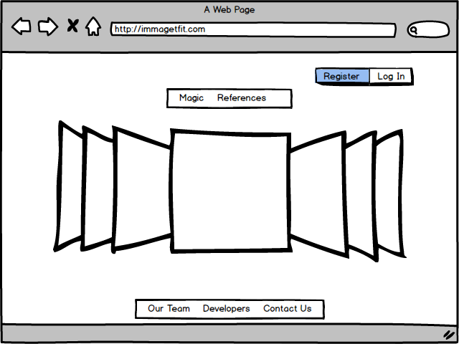

Landing page should contain a brief description of the software. Show some uses of the application and maybe a video of how to use the application and how it can help its users.

## Login

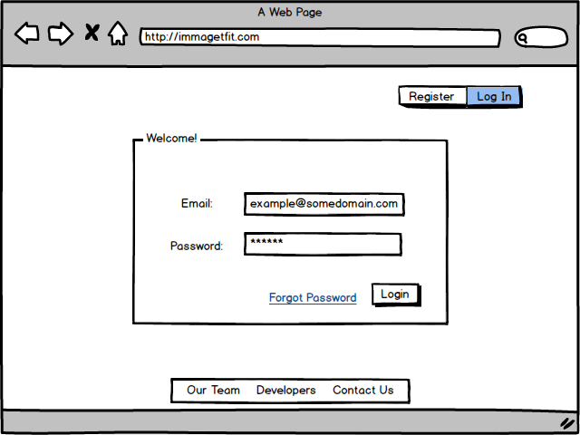

Only email will be used for identification.

## Register

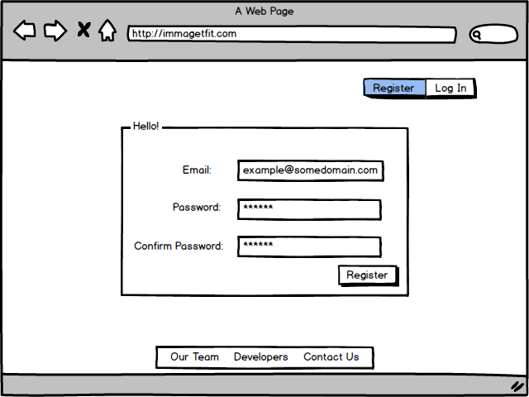

Registering should be easy and fast. Register should redirect user to the home page immediately as we would like to show our goods to lure the user.

## User Home

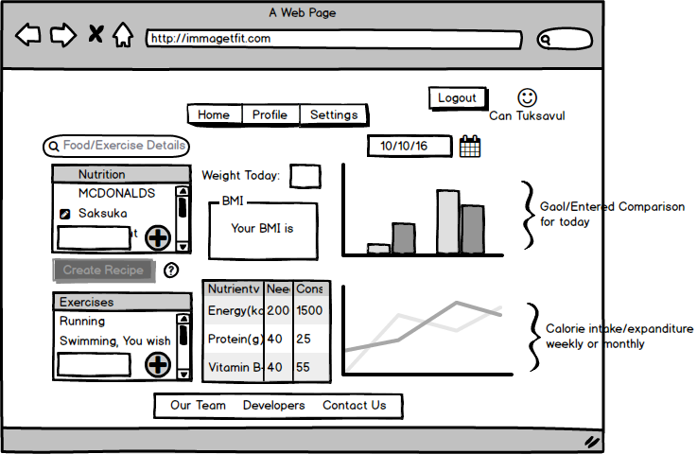

This is the main application interface of the software. User is expected to spend most of his/her time in this page. This page contains the most important functionalities of the software such as entering activity, food or weight and tracking it on a daily basis.

## Search Food

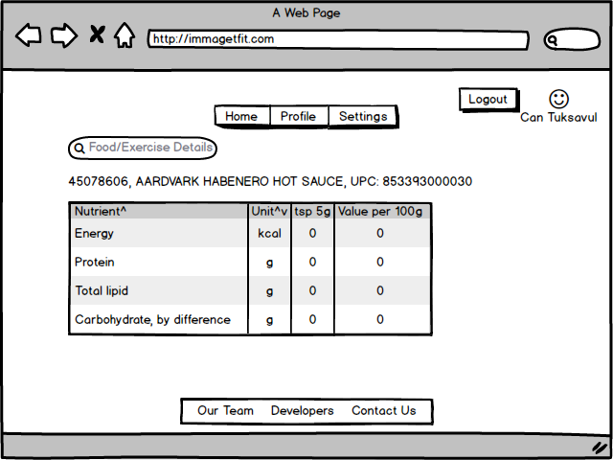

NDB API provides a big dataset. Being able to easily search for nutritional values of the food adds a decent value to the application. One can easily imagine users lengthily fiddling with the application by searching different foods.

## Profile

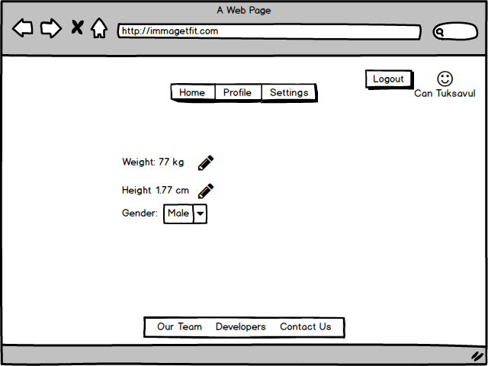

## Settings

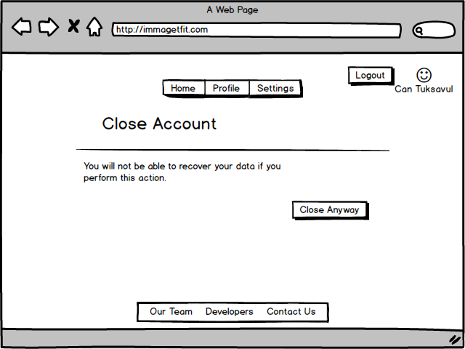

# Questions

Where to get the data of which activity will burn how much calorie?

We will be digging for this

Where to get the data of a normal calorie intake for given user profile?

A reference to this is in the project description document

How should the system handle missing data? (this requires that the reports to be generated with sparse data) example: User enters data on Monday, does not enter any data for Tuesday, enters data for Wednesday. In such a case system does not know the total intake for a given time interval.

Reports will be discrete

1. https://github.com/cantux/Fall2016Swe573cant/blob/master/docs/SWE573_projectdescription.pdf
2. https://en.wikipedia.org/wiki/Body_mass_index